In order to use a server on your machine, you have to download the software.
In order to download Node (which also comes with NPM*), go to Node's website and follow the instructions.
It'll look something like this:

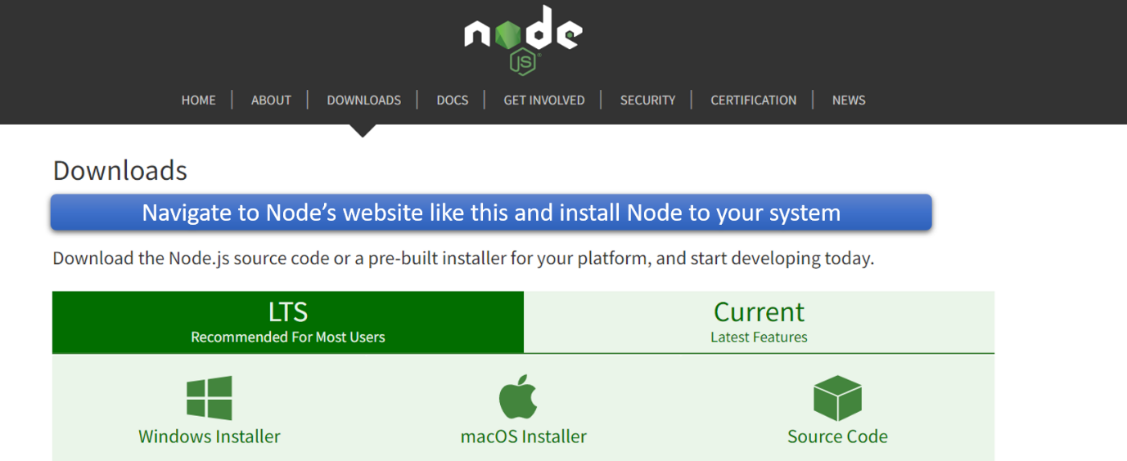

Once it's installed, you can verify its working by opening up a command prompt (or PowerShell), and typing the following:
node -v
You can do the same with NPM:
NPM -v
*NPM allows you to install Node modules. You'll see later that we will be using the Express module to set up our server. To do this, you will need to have NPM installed (but as I mentioned above, this will be done automatically if you download Node).

